AC NEGF Simulation of Nanosheet MOSFETs

Sung-Min Hong and Phil-Hun Ahn

School of Electrical Engineering and Computer Science, Gwangju Institute of Science and Technology,

123 Cheomdan-gwagiro (Oryong-dong), Buk-gu, Gwangju, 61005, Republic of Korea

E-mail: smhong@gist.ac.kr

# Abstract

In this work, an AC nonequilibrium Green function (NEGF) simulation for nanosheet MOSFETs is presented. The AC NEGF equations are discretized using a decoupled mode-space approach for efficient implementation. The Poisson equation is solved self consistently to obtain the electrostatic potential. Our in-house device simulator, G-Device, is used to simulate the AC responses on nanosheet MOSFETs.

# Introduction

The NEGF simulation plays an important role as a standard simulation method for quantum transport [1]-[3]. However, the NEGF has been mainly applied to the DC simulation. It is difficult to find transient and AC simulation results for semiconductor devices. In contrast, TCAD tools are fully capable of DC, transient, and AC simulation. Various BTE solvers [4]-[8] can solve the transient Boltzmann equation.

In this paper, the AC NEGF method is applied to nano-sheet MOSFETs.

# Methodology

The equations for the AC NEGF are summarized in Tab.1. The retarded(/lesser) Green function is assumed to be a sum of AC and DC retarded(/lesser) Green functions. These functions can be calculated following (1) and (3). Moreover, an equation for advanced Green function can be similarly expressed as the retarded Green function. The AC retarded and lesser self-energy functions are represented in (2) and (4), and the AC electron density is calculated using the above functions as shown in (5). The AC Poisson equation is implemented to obtain the electrostatic potential from the electron density.

A decoupled mode-space approach is used for an efficient implementation. Using this approach, real and imaginary parts are separated and obtained consistently with the mode-space approach. The size of the matrix is determined by the number of modes multiplied with the number of 1D real space grid points. The AC NEGF solver has been implemented in our in-house device simulator, G-Device.

# Numerical Result: Low Frequency Limit

In order to demonstrate the AC NEGF simulation, a nanosheet transistor with 5 nm 10 nm cross section, 1 nm oxide thickness, and 7 nm channel length is simulated, as illustrated in Fig.1. The effective mass Hamiltonian is employed. In addition, (001) surface and [100] channel are assumed. is set to be 0.5V. Semi-infinite leads [9] are assumed for contacts. Before the AC NEGF simulation, the DC NEGF simulation is performed. The DC simulation results are illustrated in Figs. 2, 3 and 4.

Figs. 5, 6, 7, and 8 show the results of the AC NEGF simulation at the low frequency limit. At the low frequency limit, (2) and (4) are approximated as

, (6)

, (7)

respectively. In Figs. 5 and 6, the results are compared with the quasi-static results. The transconductance and output resistance calculated by the AC NEGF simulation show good agreement with the quasi-static results. Electron densities for a drain excitation and a gate excitation are shown in Fig. 7. The electron density along the channel position is consistent with quasi-static results when the gate voltage excitation is 5 mV or 10 mV, as shown in Fig. 8.

# Numerical Result: Wideband Limit

In this section, the AC terminal current is calculated for a nanosheet transistor with 5 nm 10 nm cross section and 1 nm oxide thickness as shown in Fig. 9. The total length along the channel direction is 40 nm. The wideband limit approximation is used for contacts, only because it greatly simplifies the implementation. The DC curve is shown in Fig. 10.

The AC total current is obtained by summing the particle current and the displacement current [10]. Figs. 11 and 12 show the frequency dependence of admittance, given by and . The real part and imaginary part of the admittance are illustrated separately. It is noted that the minimum frequency(~48GHz) is related with the energy spacing in the NEGF calculation.

**Conclusions**

In summary, the AC NEGF simulation approach has been demonstrated for nanosheet MOSFETs. AC terminal currents have been evaluated under the wideband limit. The result represents that the nanoscale device exhibits complicated frequency dependence on the external voltage excitation. It is expected that the AC NEGF can be extended to more general contact models beyond the wideband limit approximation. Additionally, the proof of the current conservation under the conventional simulation set up would be an interesting future research topic.

**References**

1. S. Datta, *Journal of Physics: Condensed Matter*, vol. 2, pp. 8023-8052, 1990.
2. S. Datta, *Superlattices and Microstructures*, vol. 28, pp. 253-278, 2000.
3. S. Datta, *Quantum Transport: Atom to Transistor*. Cambridge University Press, 2005.
4. S. Tiwari *et al.*, *in Proc. IEDM*, p. 435, 1990.
5. S. E. Laux and M. V. Fischetti, *in Proc. IEDM*, p. 877, 1997.
6. Y. Koseki et al, *PRB*, vol. 93, p. 245408, 2016.
7. S. Di et al., *JCE*, vol. 15, p. 770, 2016.
8. S. -M. Hong and J. -H. Jang, *IEEE Journal of the Electron Device society*, vol. 6, pp. 156-163, 2018
9. M. J. McLennan *et al.*, *PRB*, vol. 43, pp. 13846-13884, 1991
10. Y. Wei and J. Wang, *PRB*, vol. 79, p. 195315, 2009.

|  |  |
| --- | --- |
|  | (1) |
|  | (2) |
|  | (3) |
|  | (4) |
|  | (5) |
| Table.1 AC NEGF equations. | |

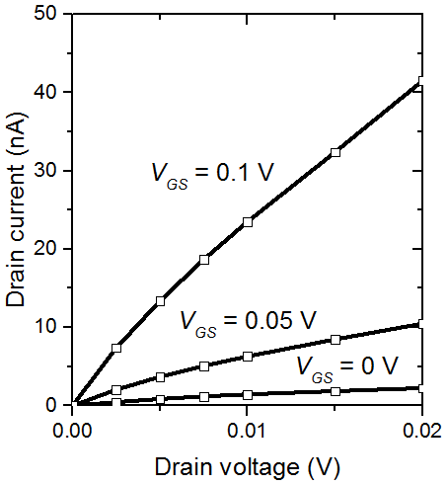

Figure 10. DC output characteristic of the nanoshe-et transistor.



Figure 11. of the nanosheet transistor at a frequency range of 48GHz to 1THz. = = 0.0V.

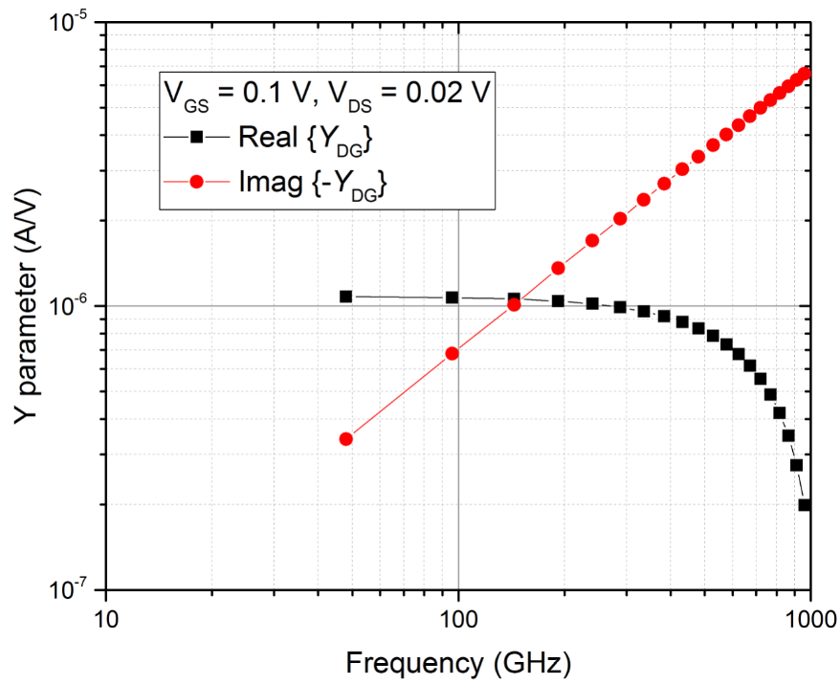

Figure 12. of the nanosh-eet transistor at a frequency range of 48GHz to 1THz. = 0.1V and = 0.02V.

|  |  |  |  |
| --- | --- | --- | --- |
| Figure 1. Nanosheet MOSFET  with 5 nm 10 nm cross section, 1 nm oxide thickness and 7 nm channel length. |  | Figure 3. DC curve of the nanosheet transistor. = 0.05V.    Figure 2. DC subband profile along the channel direction. | Figure 4. DC curve of the nanosheet transistor. |
| Figure 5. Transconductance of the nanosheet transistor at the low frequency limit. Square po-ints are results of the AC NEGF simulation. = 10 mV. | Figure 6. Output resistance of the nanosheet transistor at the low frequency limit. Square points are results of the AC NEGF simulation. = 0V. | Figure 7. Electron density a gate excitation (Red line) or a drain e-xcitation (Black line) along the cha-nnel position. | Figure 8. Electron density with a g-ate excitation along the channel po-sition. Blue dots are calculated by the AC NEGF at 0 Hz. == 0V. |
| Figure 9. Nanosheet MOSFET  with 5 nm 10 nm cross sec-tion and 1 nm oxide thickness. The wideband limit is used for contacts. |  |  |  |